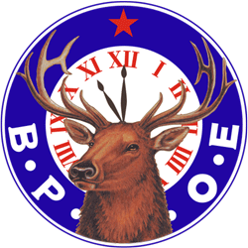

CONGRATULATIONS

MADISON ELKS LODGE #1465

BEST WISHES TO ANOTHER 100 YEARS

FRATERNALLY

2023 -2024 OFFICERS OF SPARTA ELKS LODGE #2356

EXALTED RULER – TAMMY HOWELL

LEADING KNIGHT - KEITH WALLS

LOYAL KNIGHT - ROBERT CHAGNON

LECTURING KNIGHT - RICH HOWELL

INNER GUARD - RYAN LOMACHIO

TYLER - KRISTINA BARONE

ESQUIRE - JOHN MIDDLETON (PER)

CHAPLIN - ARTHUR MURCH (PER)

SECRETARY-DOREEN MIDDLETON

TREASURER - SANDY ANDRADE

3 YEAR TRUSTEE: JEN KELLAM

2 YEAR TRUSTEE: ANTHONY ALFONSO (PSP)

1 YEAR TRUSTEE: ALICIA MURCH